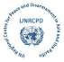

**UNITED NATIONS REGIONAL CENTRE FOR PEACE AND DISARMAMENT IN ASIA AND THE PACIFIC**

**KSK Building, 4th Floor, Ward No. 5, Lagankhel, Lalitpur, Nepal • Email: info@unrcpd.org**

page1image3152275120

**UNODA’s Regional Centre in Asia and the Pacific concludes webinar series on gender and small arms control in Papua New Guinea**

As travelling in the Asia-Pacific region remains challenging in the wake of the Covid-19 pandemic, [the United Nations Regional Centre for Peace and Disarmament in Asia and the Pacific (UNRCPD)](https://unrcpd.org/) adapted a planned national training on gender and small arms control for government officials from Papua New Guinea into a webinar series. The four-part series, conducted in partnership with the Office of Prime Minister and National Executive Council (NEC) of Papua New Guinea, were held on 23,24and 30 September and 1 October.

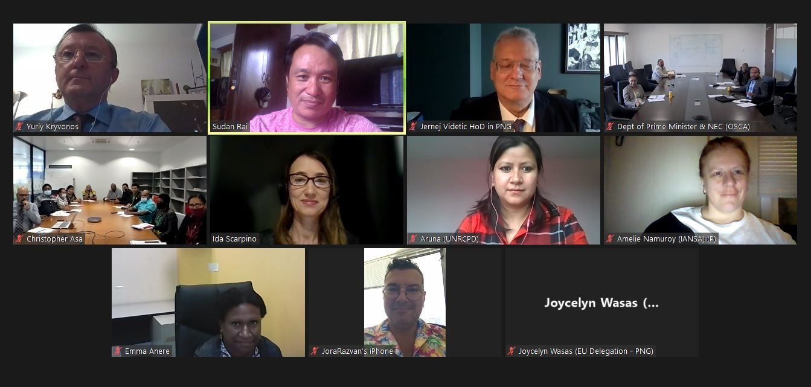

***Figure 1:*** *Group photo of UNRCPD staff, the EU delegation, experts and twenty-one national participants from various governmental agencies and civil society.*

The webinars covered the topic of gender mainstreaming small arms control at the normative, policy and regulation, and operational level. They drew twenty government officials (10 women and 10 men), representing the following agencies: the Office of Prime Minister and NEC, the Office of the Security Coordination and Assessment (OSCA), the Law and Order Branch, the Special Parliamentary Committee on Gender Based Violence prevention, the Department of Foreign Affairs and International Trade, the Department for Community Development and Religion, the Office for the Development of Women, the Royal Papua New Guinea Constabulary – Directorate for Family and Sexual Violence. Mr. Tweedy Malagian, founder of civil society organisation *Seeds for Peace* andmember of [the International Action Network on Small Arms (IANSA) network](https://iansa.org/) attended the series to share grassroot experiences on gun violence prevention in Papua New Guinea.

***Figure 2:*** *Participants joined in open discussion on relevant normative frameworks on gender and small arms control in Papua New Guinea.*

Opening the first webinar, H.E. Ambassador Jernej Videtic, Delegation of the European Union (EU) to Papua New Guinea noted that armed violence and its gendered impacts is of particular concern in the Pacific, adding that the EU continues to support the integration of gender-related global commitments on small arms control intro regional, national and local practices, His speech was followed by the opening remarks of Mr. Christopher Asa, Director General, Social Policy & Governance Department of Prime Minister & NEC, who also serves as the National Focal Point on the [UN Programme of Action to Prevent, Combat and Eradicate the Illicit Trade in Small Arms and Light Weapons in All Its Aspects (PoA)](https://www.un.org/disarmament/convarms/salw/programme-of-action/) and Dr. Yuriy Kryvonos, Director of UNRCPD.

The issue of gender-based violence and the presence of small arms as an enabler of such violence featured prominently in the first two webinars, reflecting the urgency of this issue in Papua New Guinea. Participants engaged in discussions, led by Ms. Ida Scarpino, UNRCPD Regional Project Coordinator, about the synergies between small arms and light weapons (SALW) control and key domestic frameworks such as gender-based violence (GBV) prevention and community safe programmes. They discussed and examined relevant normative frameworks such as the National Strategy to prevent and respond to GBV 2016-2025 and the [Spotlight Initiative](https://spotlightinitiative.org/where-we-work?region=pacifique), whose pillars and activities were presented by Ms. Emma Anere from the [UN Women Country Office](https://asiapacific.unwomen.org/en/countries/png#:~:text=UN%20Women%20Papua%20New%20Guinea%20Papua%20New%20Guinea,committed%20to%20working%20together%20%E2%80%93%20and%20UN%20).

On the second day, participants engaged in a role-play exercise describing a case of gender-based violence committed with small arms which showed the circumstances and chain of events that can contribute to failing to prevent the crime and to convict the perpetrator. This was followed by a fruitful discussion on (armed) gender-based violence and potential loopholes in legislative frameworks and coordination mechanisms, such as the lack of checks for criminal background or other GBV indicators for those applying for a firearms licence, and the lack of information sharing among law enforcement institutions to report and convict cases of GBV. Mr. Steven Paniu from the [United Nations Population Fund (UNFPA) Country Office](https://png.unfpa.org/) and Mr. Tweedy Malagian from *Seeds For Peace* provided data on gender based violence and shared testimonies on the implications of gun violence and the role of toxic masculinity in perpetuating the problem.

***Figure 3:*** *On the third day, participants joined in a brainstorming exercise on ways to improve the Firearms Act 1996 to prevent violence against women perpetrated with small arms.*

The third webinar focused on strengthening Papua New Guinea’s national legal framework to address gender-based violence and the enabling role of small arms and light weapons. Mr. Dragan Bozanic, from the [United Nations Development Programme - The South Eastern and Eastern Europe Clearinghouse for the Control of Small Arms and Light Weapons (UNDP-SEESAC)](https://www.seesac.org/) shared his experience working with National Commissions on SALW in South Eastern and Eastern Europe to promote the collection of sex-and-age disaggregated data in SALW control and reviewing SALW related legislation to include reference to GBV. The presentation led to a productive discussion on a series of practical recommendations for amending Papua New Guinea’s Firearms Act 1996. One such recommendation made reference to the importance of having a National Coordination Mechanism on SALW control to promote effective reforms and measures. Another recommendation underlined the key role of civil society and women in ensuring that gender perspectives are included at all levels. In this regard, Ms. Amelie Namuroy from the International Action Network on Small Arms (IANSA) provided examples of how civil society and women are contributing to this goal globally.

On day four, participants and experts discussed how to operationalize the issue of gender and small arms control. Mr. Alistair Gee from the [Centre for Armed Violence Reduction (CAVR)](https://armedviolencereduction.org/) spoke on current technical assistance programmes for SALW control in Papua New Guinea and entry points for gender-responsiveness. He presented available tools and programmes that countries can use to improve their operational capacity in small arms control, with a focus on the [Arms Tracker initiative](https://armstracker.org/).

The series concluded with an exercise aimed at identifying action points and a series of recommendations to enhance SALW control in Papua New Guinea from a gender perspective, which will be further considered at a forthcoming follow-up activity. The list of recommendations included, among others, measures aimed at improving the regulatory framework on SALW control and the development of broader community safety programmes and disarmament education initiatives in the lead up to Papua New Guinea’s elections next year.

***Figure 4:*** *Day four, participants discussed ideas aimed at improving the national infrastructure on SALW control and developing broader community safety programmes and disarmament education initiatives.*

The webinar series was part of [a global project](https://www.un.org/disarmament/gender-and-small-arms-control/) in support of gender mainstreamed policies, programmes and actions in the fight against small arms trafficking and misuse, in line with the Women, Peace and Security agenda, funded by the European Union.