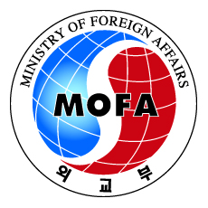 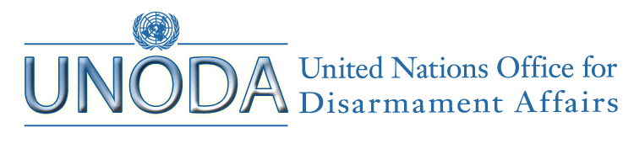

**13th Republic of Korea-United Nations Joint Conference**

**on Disarmament and Non-proliferation Issues**

***"Looking Ahead: Opportunities and Challenges in Disarmament and Non-proliferation"***

**4-5 December 2014, Seoul, Republic of Korea**

**Agenda**

**Session 1:**

**Treaty on the Non-proliferation of Nuclear Weapons:**

**Challenges and Tasks Ahead**

**Building Momentum Towards the 2015 NPT Review Conference**

**Addressing the Challenges for the 2015 NPT Review Conference, including the Issue of Withdrawal from the NPT**

**Session 2:**

**Coping with Emerging Issues in Disarmament and Non-proliferation**

**Evolving Artificial Intelligence: Autonomous Weapons Systems**

**Session 3:**

**Regional Non-proliferation Issues**

**North Korean Nuclear Issue: Threats and Responses**

**Iranian Nuclear Issue: A Comprehensive Solution**